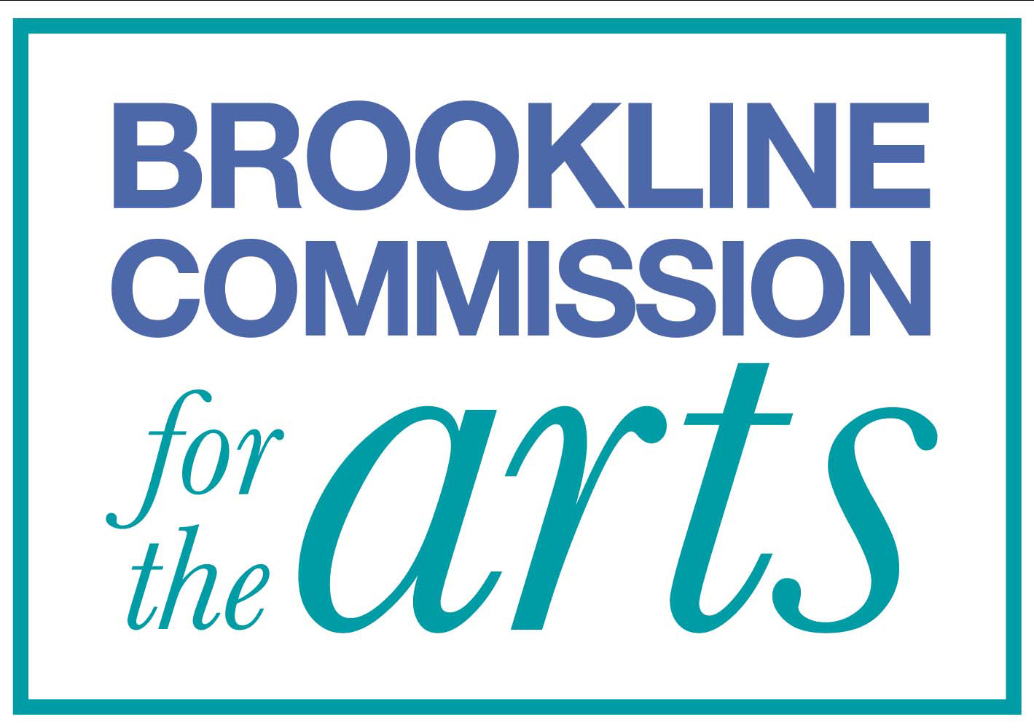

Town Hall Walls

APPLICATION FORM

NAME: DATE:

ORGANIZATION (if applicable):

ADDRESS:

TELEPHONE(s):

EMAIL:

The Town of Brookline does not hold insurance for art work on exhibit and is not responsible for loss or damage to any artwork. Each artist will be required to sign a Waiver, Release and Indemnification Agreement prior to acceptance of any work or object for display.

The Town of Brookline or Brookline Commission for the Arts is not responsible for lost or damaged applications or materials.

Signature Date

Parent's Signature (for minors) Date

